**TEMPERATURE CHECKER APPLICATION USING GNUSin8085**

**NAME: VINOTHA MURUGAN**

**CLASS: SYBSCIT**

**ROLL NO:18070**

**SUBJECT: VSC (PROJECT)**

**SUBMITTING TO: GAYATRI MAM**

**TITLE:**

**TEMPERATURE CHECKER APPLICATION USING GNUSim8085**

**AIM:**

**To write a simple 8085 assembly language program that checks whether the given temperature is Hot or Normal and stores the result in memory.**

**ALGORITHM:**

**1. Start the program.**

**2. Load the temperature value from memory location 2050H.**

**3. Compare the temperature value with 30°C (1EH).**

**4. If the value is less than or equal to 30°C, store 00H in 2051H (Normal)**

**5. If the value is greater than 30°C, store 01H in 2051H (Hot).**

**6. Stop the program.**

**PROGRAM:**

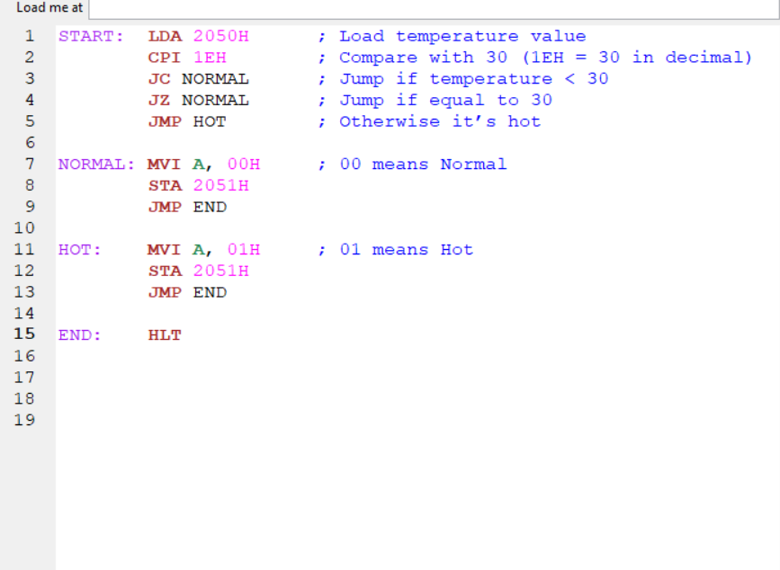

**OUTPUT:**

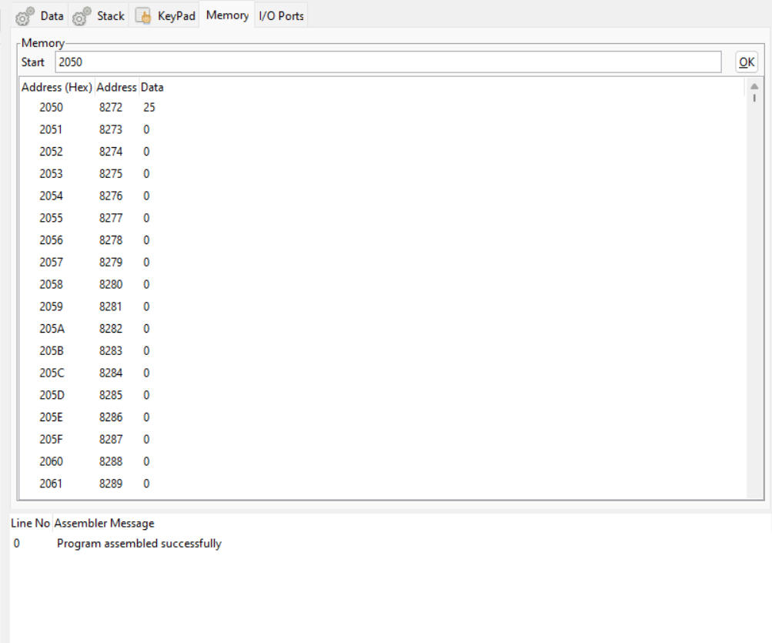

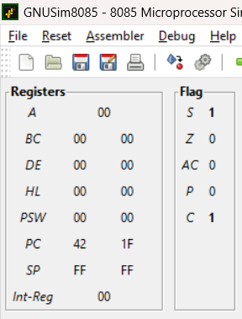

1. **INPUT (2050H)**

**OUTPUT (2051H)**

**25 00 NORMAL**

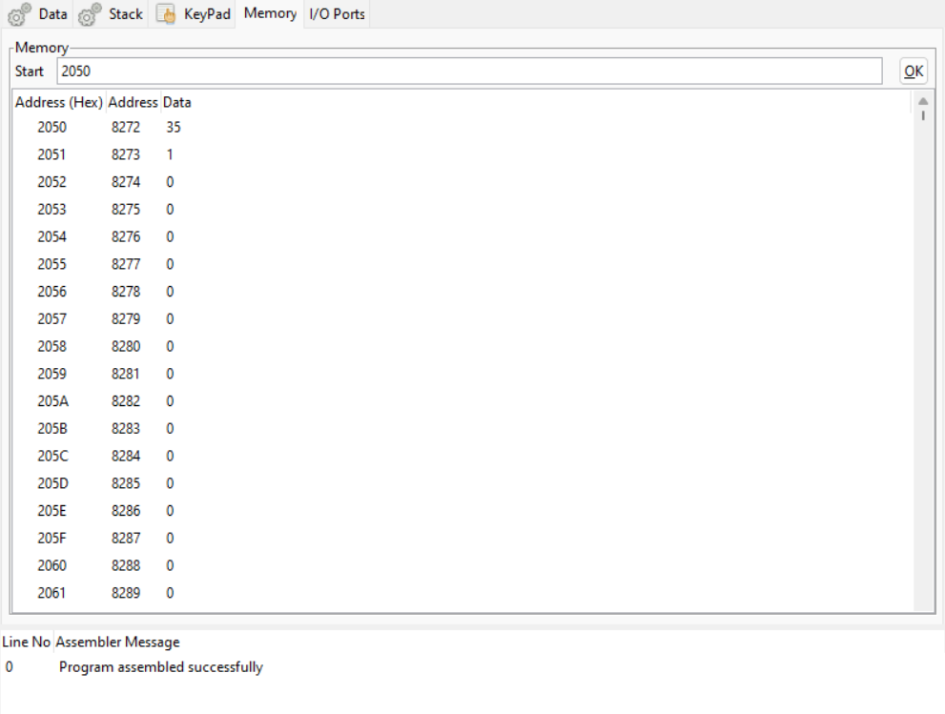

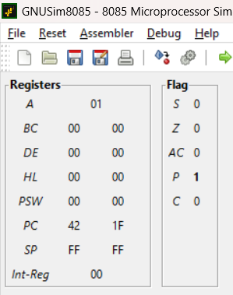

**2. INPUT (2050H)**

**OUTPUT (2051H)**

**35 01 HOT**

**Output Table:**

**Input (2050H) Output (2051H) Meaning**

**25 00 Normal**

**35 01 Hot**

**Result:**

**The 8085 assembly program was successfully executed. It correctly identifies the temperature as Hot or Normal based on the input value and stores the result in memory.**

**CONCLUSION:-**

**The above program has been executed successfully.**

**THANKYOU**